Parents’ Guide to Student Success in *Mathematics*

*Fourth Grade*

**Why Are Academic Standards Important?**

Academic standards are important because they help ensure that all students, no matter where they live, are prepared for success in college and the workforce. Standards provide an important first step — a clear roadmap for learning for teachers, parents, and students. Having clearly defined goals helps families and teachers work together to ensure that students succeed. They also will help your child develop critical thinking skills that will prepare him or her for college and career.

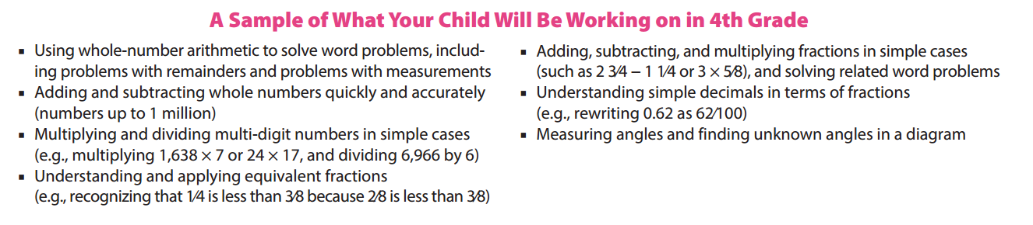



**Help Your Child Learn at Home**

Try to create a quiet place for your child to study, and carve out time every day when your child can concentrate. You should also try to sit down with your child at least once a week for 15 to 30 minutes while he or she works on homework. This will keep you informed about what your child is working on, and it will help you be the first to know if your child needs help with specific topics. Additionally, here are some activities you can do with your child to support learning at home:

*Look for “word problems” in real life. Some 4th grade examples might include:*

* Ask your child to compare numbers using phrases like “times as much.” For example, if the family cat weighs 8 lbs. and the family dog weighs 56 lbs., how many times as much does the dog weigh?
* Ask your child to help you compare fractional amounts — for example, if one recipe calls for 2⁄3 of a cup of oil, but another recipe calls for 3⁄4 of a cup of oil, which recipe calls for more oil? (In 5th grade, your child will learn ways to determine just how much more oil.)

Resource: <http://www.pta.org/parents/>

**Fourth Grade**

Nine Week Checkpoints for Parents and Students



|  |  |
| --- | --- |
| **First Nine Weeks** | **Second Nine Weeks** |
| *Helpful websites to help students master the first and second nine week concepts:*  [*https://www.khanacademy.org/commoncore/grade-4-NBT*](https://www.khanacademy.org/commoncore/grade-4-NBT)  [*https://www.khanacademy.org/commoncore/grade-4-OA*](https://www.khanacademy.org/commoncore/grade-4-OA)  [*https://www.khanacademy.org/commoncore/grade-4-NF*](https://www.khanacademy.org/commoncore/grade-4-NF) | |
| *Students should know and be able to:*   * Read and write whole numbers using numbers, number names, and expanded form * Compare multi-digit numbers * Round multi-digit numbers to a given place * Solve multi-step word problems using addition, subtraction, multiplication, and division. * **Fluently add and subtract multi-digit numbers using the standard algorithm**1 * Name all factors of all whole numbers 0-100 * Multiply whole numbers (4 digits x 1 digit, 2 digits x 2 digits) * Model and divide up to 4 digits by 1 digit | *Students should know and be able to:*   * Create equivalent fractions * Compare two fractions with different numerators * Add and subtract fractions and mixed numerals with the same denominators * Multiply a fraction by a whole number * Solve word problems involving multiplication of a fraction by a whole number * Put together and take apart fractions using addition and subtraction |
| **Third Nine Weeks** | **Fourth Nine Weeks** |
| *Helpful websites to help students master the third and fourth nine week concepts:*  [*https://www.khanacademy.org/commoncore/grade-4-NF*](https://www.khanacademy.org/commoncore/grade-4-NF)  [*https://www.khanacademy.org/commoncore/grade-4-G*](https://www.khanacademy.org/commoncore/grade-4-G)  [*https://www.khanacademy.org/commoncore/grade-4-MD*](https://www.khanacademy.org/commoncore/grade-4-MD) | |
| *Students should know and be able to:*   * Add fractions with denominators of 10 and 100 * Use decimals to describe fractions with denominators of 10 and 100 * Compare two decimals to the hundredths place * Show decimals on a number line * Identify parallel and perpendicular lines * Classify shapes based on lines and angels * Symmetry | *Students should know and be able to:*   * Compare larger and smaller units * Draw and measure angles * Find area and perimeter of a given shape * Solve area and perimeter word problems |

***1 After students have a conceptual understanding of adding and subtracting multi-digit numbers*.**